
Automated Arduino Traffic Light

Objective:
In this assignment, you will build and program a fully automated traffic light system using an Arduino Uno micro-controller and Tinkercad Circuits. You will write code (using visual Blocks or C++ text) to cycle through Red, Yellow, and Green LEDs in a real-world sequence.

Name : ABDUL HARIZ B. MOHD SARNUDIN
Student ID : CBS24070208
Semester/Trade/Group : 5 / DCBS / CBS 1
TTO : SIR LUQMAN HAKIM B. MOHD SABANI
Required Components (Tinkercad Circuits)
- 1x Arduino Uno R3
- 1x Small Breadboard
- 3x LEDs (1 Red, 1 Yellow, 1 Green)
- 3x 220 Resistors
- Jumper Wires
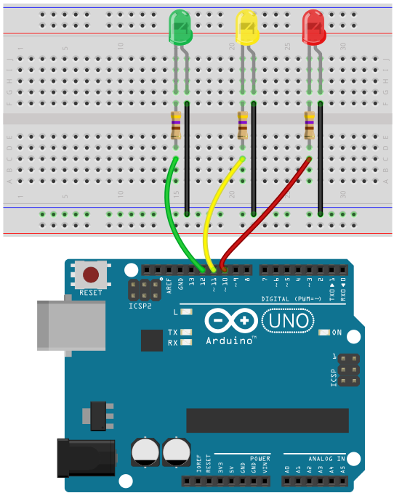
Step-by-Step Instructions
Part A: Wiring the Circuit
- Open Tinkercad: Click the Tinkercad attachment in this assignment to launch the workspace.
- Create Circuit: Go to Designs > Create > Circuit.
- Place Components: Add the Arduino Uno and Small Breadboard to your workplane.
- Connect Ground (GND): Wire a GND pin from the Arduino to the negative (-) rail on the breadboard.
- Place LEDs: Place 3 LEDs side-by-side on the breadboard and change their colors to Red, Yellow, and Green.
- Add Resistors: Connect a 220 Resistor from the Cathode (short leg) of each LED to the negative (-) ground rail.
- Connect Digital Pins:
  - Wire Digital Pin 12 to the Anode (long leg) of the Red LED.
  - Wire Digital Pin 11 to the Anode (long leg) of the Yellow LED.
  - Wire Digital Pin 10 to the Anode (long leg) of the Green LED.

Part B: Programming the Traffic Light
- Click the Code button in the top right toolbar (set editor mode to Blocks or Blocks + Text).
- Program the sequence using pin output blocks and delay commands:
  - Red Light: Set Pin 12 HIGH 🡪Wait 3 seconds 🡪 Set Pin 12 LOW.
  - Green Light: Set Pin 10 HIGH 🡪Wait 3 seconds 🡪 Set Pin 10 LOW.
  - Yellow Light: Set Pin 11 HIGH 🡪Wait 1 second 🡪 Set Pin 11 LOW.
- Click Start Simulation to test if your lights cycle continuously in the correct traffic order.
Part C: Submission
- Click Send To (top right corner) > Share to Google Classroom to turn in your project.
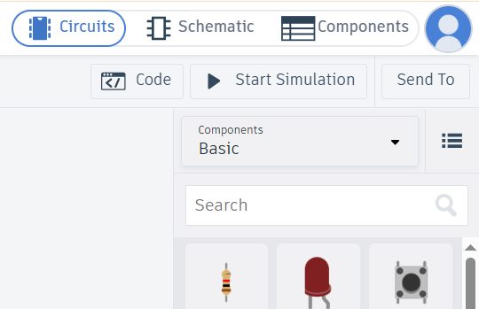

Copy and paste your diagram:
Example:

